# Emre Altunsu

**Personal Profile**

Name: Emre Altunsu

Student Number: s3942994

Student Email: [s3942994@student.rmit.edu.au](mailto:s3942994@student.rmit.edu.au)

Background: Turkish, Born in Melbourne, Victoria, Australia

Personal Hobbies: Some of my general hobbies include collecting vintage trading cards, household cleaning, purchasing memorabilia from well-known movies like Star Wars and Lord of the rings. Another major hobby is volunteering for charity organizations such as Cancer council fund raisers and charity food stalls

Experience in IT- My level of knowledge and skill regarding information technology is currently extremely limited. Leaving secondary school in 2021, I have a certificate 3 in business under my belt. Although in recent months I have been supporting my family in repairing home technologies such as television systems and home security systems. Through my current enrollment in a bachelor’s degree in information technology, I will be able to extend my knowledge in topics relevant to my aspirations and overarching goal within the industry

Myer-Briggs Personality Test Results

Through the completion of the Myer-Briggs tests results, I was able to confirm and further understand my personal strengths and weaknesses in a variety of ways. Results highlight that at times I am both rational and determined, which perfectly reflects my current way of thought and reasoning in my studies. The main group I have been categorized in is as expected the ‘Architect’. Results suggest that as an individual, I can achieve much through independent and honest way, however I fail to understand my emotions, often remaining dismissive and overly critical in most aspects of life. Conclusively, these results provide a basis in which I can visualize the type of individual I currently am and how I can improve myself through increased collaboration with others who share similar values, resolving of degrading personal doubts and conflicts as well as by seeking more difficult challenges to further myself as a budding IT student and professional.

Learning Styles Test

Extending on my evaluation of personal strengths and weaknesses, the method of analyzing my preferred leaning style may help in understanding how to correct my individual flaws. Results demonstrate that auditory and visual methods of learning are a source of strength in my case. According to the results, my ability to remember individuals via their facial features, overall body language and persona can be extremely useful within a professional sense. When new elements of a topic or subject are presented, I can effectively take notes and visualize this information via summative diagrams or charts. Analysis of this outcome can propose that my abilities at establishing a ground understanding of any form of information at times can be difficult but providing a visual representation or explanation of this information can better consolidate my understanding of what is important and/or required.

Strengths: Creativity, dedication, disciplined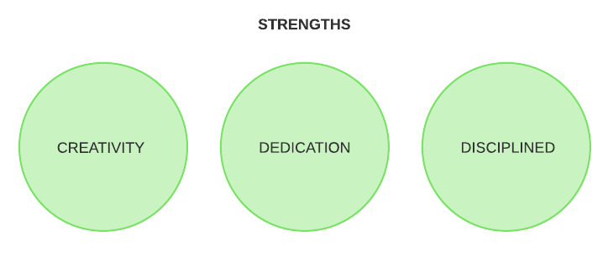

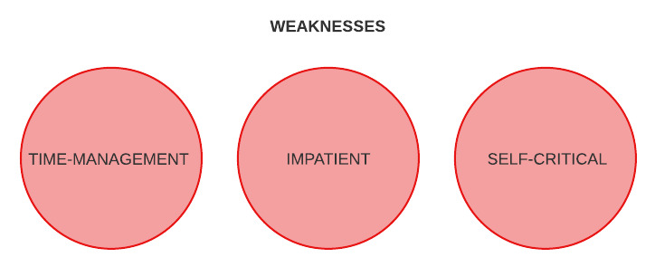

Weaknesses: Time management, patience, self-critical

Ideal Employment

Current Occupation: Currently Unemployed, Studying at RMIT

Future Occupation: IT system support Analyst

Gaining experience will be a key requirement to achieve my goal of becoming an IT system support analyst. After extensive research on websites including seek.com and through sources like Google and YouTube I was able to determine the regular entry requirements regarding similar positions. A great majority of positions required a Bachelor of Information Technology, which is the main reason I chose to pursue it at the beginning of this year. Similar positions also require an understanding of SQL language, user authentication and experience in working with tools such as SQL database systems and preferably some form of coding language. Although an IT system support analyst is strictly categorized as an IT role, many employers seek individuals who can cooperate effectively in a team environment and follow the basic workplace principles including being able to manage individually assigned duties. The form of employment I envision includes an autonomous yet involving nature, with a minimum salary of between 70k to 80k to ensure I’m both comfortable and able to achieve a general sense of fulfillment and accomplishment.

# Jack Gale

Name: Jack Alan Gale

Student Number: s3286616

Email: s3286616@student.rmit.edu.au

Background: Melbourne, Australia

Hobbies: I enjoy playing piano and listening to classical music. It is my life’s goal to play all of Frederic Chopin’s Nocturnes and to express the music of some of history’s greatest composers.

I.T. Interest: Data Analysis, Machine Learning, Software Design & Implementation, Sound Engineering.

I.T. Experience: As a Business Analyst I am exposed to many facets of technology and business. I am the bridge the connects technology to operations and it is my responsibility to improve operations through technology solutions, which I have achieved utilising Six Sigma DMAIC and Agile Software Development. As an agent of change I am involved in the end-to-end process of product control; this involves facilitating meetings with developers, showcasing requirements, building quality assurance test cases and training users on the front-line.

**Personality Test**

My results from the Myer Briggs Personality test seem to align with most of the traits from The Big Five Personality Test. Both tests suggest that I am high in creativity and imagination, this includes brainstorming ideas in a group setting. Challenging the status quo and idea sharing is advantageous when working within a team because it allows everyone’s opinion to be valued. Scoring high in openness implies that I enjoy unique self-expression which is great for leadership, building teams and innovation. Leaders must think freely to design innovative products and reinvent businesses processes, knowing that I possess these traits shapes confidence toward becoming a leader in the technology space.

**Adobe Creative Test:** My results suggest that I am a ‘Thinker.’ A Thinker has intellectual curiosity and always tries to find and create meaning. Leaders must instill and drive meaning in projects to keep employees motivated. Gartner’s hype cycle suggests that long-term technology projects deal with fluctuating levels of enthusiasm, therefore keeping morale high is a challenge throughout the project’s life. Defining meaning and motivation with each member's contribution to the team is imperative to boost spirits.

Strengths: Innovation, Problem-Solving, Risk Mitigation.

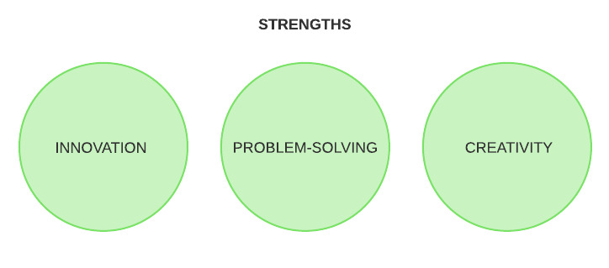

Weaknesses: Indecisive, Empathetic, Time-Management

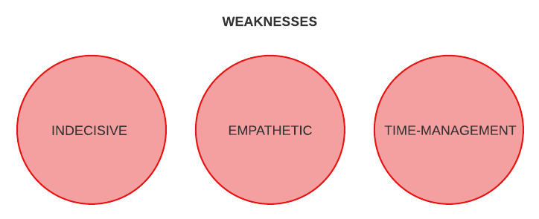

**Ideal Job:** Software Engineer Lead

Building the architecture in the back-end and influencing the design at the front-end, Software Engineers challenge their problem-solving and design skills every day. This position appeals to me because it is an opportunity to express my creativity through technology, much like playing piano mentioned at the beginning of my profile.

# Yousef Fares

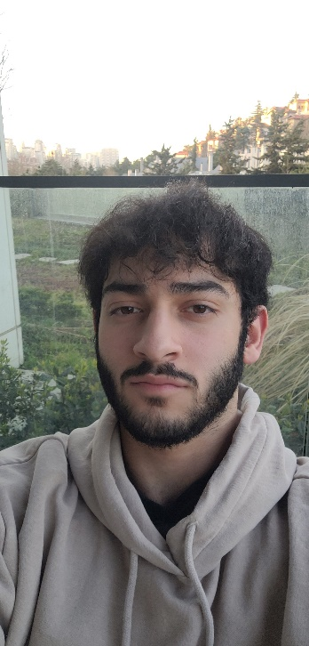

**Name:** Yousef Fares , **Student Number:** s3955987 , **Email:** s3955987@student.rmit.edu.au

**Strengths**

Analysis / Working with a group / Working alone / Problem solving / Programming (to an extent)

**Weaknesses** 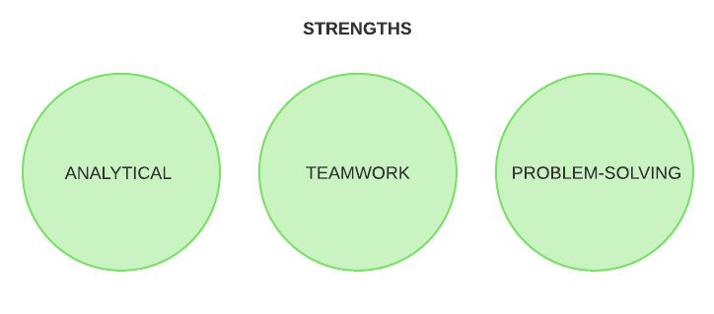

Time management / Not creative / Indecisive / Waffle a lot / Not the best at English

**Background**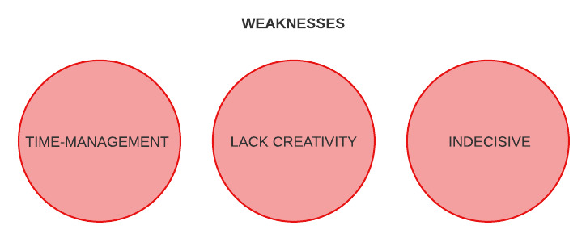

Arabic – Born in Melbourne, Australia. Spent pretty much the entirety of my life in the middle east.

**Personal Profile**

Hey! I’m Yousef Fares, s3955987, and I’m currently performing a Bachelor of Information Technology at RMIT. I’m, simply put, way too addicted to games and movies. Although I’m Australian and really looking forward to coming back to live in Australia for the first time since 2005, I’m originally Arabic and have lived most of my life in the Middle East. I’ve picked up on numerous cultural aspects of life in the UAE, Qatar, Jordan, and Turkey – they’re all unique and countries worth visiting if you haven’t already. I love doing anything that isn’t productive; I’ve been trying to catch up on the MCU timeline recently, been playing a ton of CoD: Cold War, and enjoy going to the gym to clear my mind. I’m fascinated by computer science in general but primarily interested in the different applications of AI and would really like to build some form of career in it. Although I haven’t gotten any industry experience, I am pretty comfortable with coding in Python and am alright developing websites with HTML and CSS.

**Personality Tests**

Overall, my personality tests look relatively accurate. The learning style test mentions I’m a ‘Tactile’ learner which I find to be true. Learning subjects that seem to have a lot of hypothetical aspects to it like Business Studies has always been my downfall, whereas I enjoy working on programming as I find it to be quite hands-on. Learning comes in the form of practice, and I’ve found myself learning skills in doing so a lot more effectively than not. Moreover, the Myers-Briggs test mentions me being an ‘Assertive Consul’ (ESFJ-A) which highlights characteristics like punctuality, neatness, responsibility, productiveness, and with a concern for the needs of others. Finally, in short, I’m not creative. The traits ‘Persistence’ and ‘Perspective’ which I scored on relatively high and true. I tend not to allow myself to move onto another activity until I’ve finished off the one I’m currently working on. Additionally, I find myself able to consider ideas or claims from different perspectives. However, the Complexity may be true so long as I’m working with tasks I enjoy. As in, I’m alright working long hours on a large-scale programming project but dread working on business studies. I hate business studies.

**Personality Test Results Images**

1. 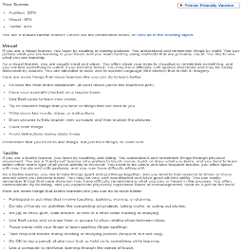
2. 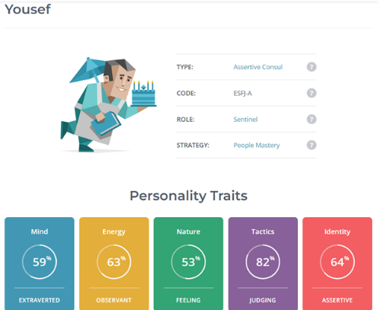
3. 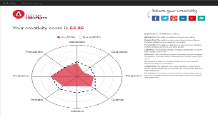

**Ideal Job: Machine Learning Engineer**

Although difficult, it generally pays well. Machine Learning has a lot of real-world applications and the potential to solve global issues – seeing my work used to address real-world problems is always nice. It’s quite demanding in terms of academic requirements but I’m willing to work towards it. It looks like it consists of components of data analysis and teaching computers how to recognize data patterns.

# Dominic Hutchinson



**Name:** Dominic Hutchinson

**Student Number:** S3943438,

**Email:** [S3943439@student.rmit.edu.au](mailto:S3943439@student.rmit.edu.au)

**Background:** South-East Melbourne, Australia

**Hobbies:** IT, Media, Reading, Writing, Casual Gaming.

**Strengths:** Innovation/Creativity, Problem Solving, Analysing**O**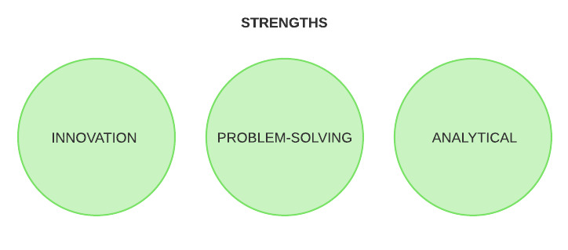

**Weaknesses:** Easily Overwhelmed, Time Management, Trouble committing myself to specific tasks.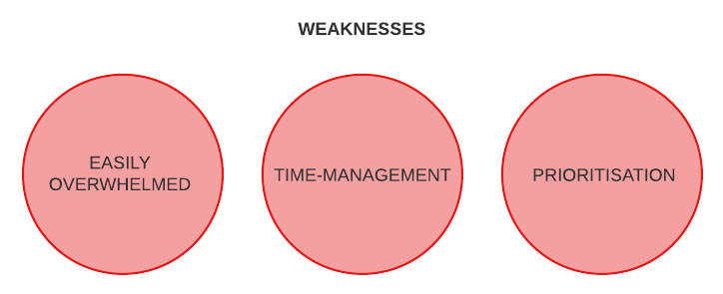

**Technology Interest/Experience:** Tech has always been quite a major part of my life, innovating new ways of thinking and connecting with people and their emotions, making my disability (High Functioning ASD) navigable. I always felt that I understood computers more than I did people. I found that programming in VCE Computing was an enjoyment to me, so I sought out universities which could offer me the opportunity to learn how to properly program in ae business setting. In regard of what I wish to pursue, I am still coming to terms of exactly the field I want to follow, although I hope to go down a path where I may be able to help people who need technological solutions and also be able to help tell stories through a technological medium, to perhaps encourage a different way of thinking.

**Personality Tests:** According to the Myer-Briggs 16 Personality Test, I am an Advocate (INFJ-T) which outlines that I am a thoughtful, curious, imaginative, feeling-orientated person, who is decisive yet also sensitive to build up of emotion. To me, this classifies me as a problem solver, and creator of ideas, while having trouble creating the solid construction of a manifested idea, more looking towards making innovative ways to solve problems.

The Big 5 Personality Test shows similar results, while also stating that I am careful and diligent, as well as thoughtful, which benefit playing a supportive, yet contributive role in a group setting.

The Learning Styles Test states that my learning style consists of theoretical and reflective learning, solving problems logically and through organisation, while also standing back and observing, collecting and analysing information, then applying this learning to new ideas and theories.

**Ideal Job:** My Ideal Job would be to work as a Software Developer, responsible for creating, testing and updating programs and software for clients on both front and back end development. This appeals to me as it combines both aspects of creativity front-end, and logic-based programming back-end, fully taking realisation of my skill set of innovation and creativity. This kind of job also allows on-the-go problem solving, which would benefit my skill set even more.

# portrait imageMark Schroeder

Student number: s3895337

Email: [s3895437@student.rmit.edu.au](mailto:s3895437@student.rmit.edu.au)

Background: South-East Melbourne, Australia

**Personal information:**

I have always been fascinated by computers and computer programming. During my high school years, I learned how to build circuits and program them using Arduino (C++). Due to my interest in this field, I am studying a Bachelor of Information Technology (IT) at RMIT. I already hold a Certificate III in Information Digital Media Technology and a Certificate II in Small Business (Innovations/Operations). I also studied software development in my Victorian Certificate of Education (VCE) and look forward to developing these skills further. On a more personal note, I play the guitar (although not very well), I have two brothers, and I have a cat named Monty.

**Personality tests:**

My personality type (Myers-Briggs) test result indicates that I am a strong thinker with a score of 62% thinking over 38% feeling. This is a relevant attribute of my personality regarding group work as I may be lacking in some social skills, but I can still bring an intuitive and prospective view to issues that the team will need to tackle. Additionally, my assertiveness trait can have an influence on my performance within a team as this can elicit qualities of leadership. This can be very useful to a team as it can provide direction and encouragement which can bolster the team’s ability to meet deadlines.

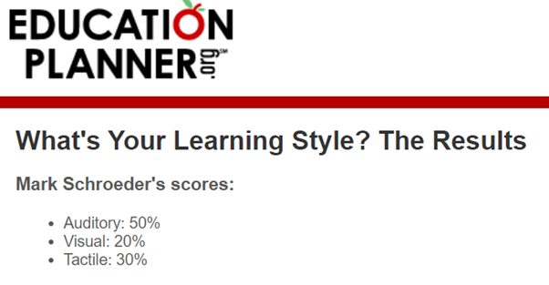In my creativity test (Test My Creativity) I scored lower than typical in ‘connection’. This again, highlights my lack of social abilities, but interestingly, according to my creativity test, I possess a higher than typical ‘complexity’. This will hopefully support our team’s ability to come up with new and detailed ideas.

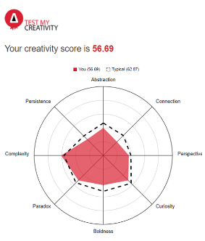**Ideal job: IT manager**

After working in IT for a short time, I have realised that I would like to lead a team in this field. I believe I have good allocation and management skills and I possess a strong passion for technology so a management position in IT seems like a good fit for me. This job gives one the responsibility of managing people as well as overseeing day to day operations. Due to this high level of responsibility, IT managers are usually paid handsomely, this is another attraction to this role I have.

# 

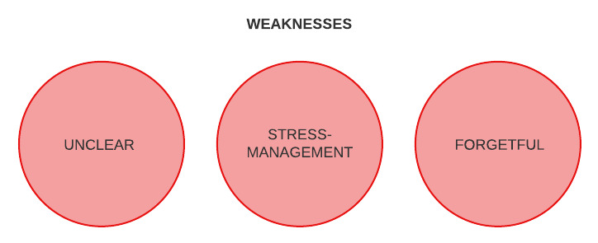

# Gabriel Jones

**Personal Profile/IT interest/experience:**

The next member of our group is Gabe Jones (3957629). He was born in Brisbane and moved to Tasmania in around 2015. After graduating from Launceston College in 2019, he originally decided to focus on becoming an electrician, studying an introductory course in Electrotechnology throughout year 12. After receiving a certificate II, he studied and worked part time up until 2022. Now studying a Bachelor of Information Technology at RMIT, he hopes to discover what field he will enjoy the most inside the industry. He has been playing video games for most of his life and enjoys many different genres.

Gabe has never worked in an IT related job but after spending a lot of time working with and using computers, his general computing knowledge is above average. As a career, he is excited to work in a more complicated and demanding role where there are many aspects to learn overtime. Visualizing and creating something that solves a problem has always been at the top of his list in career outcomes. He is mainly interested in areas such as computer graphics, hardware, and gaming.

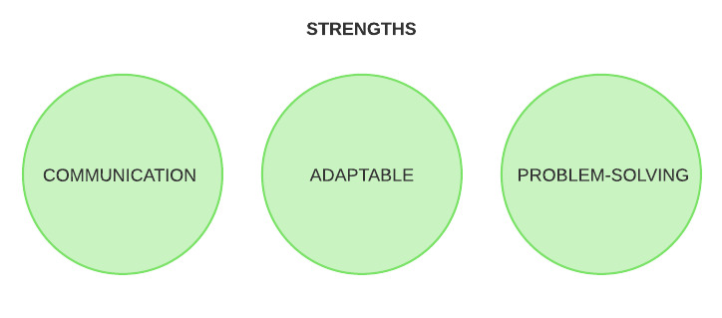  
**Personality Test results:**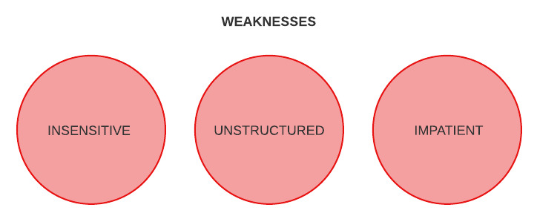

Gabe’s Myer-Briggs test results showed that he mostly aligned with the entrepreneur type. ESTP-A love to be the center of attention, laughing and entertaining with a blunt and earthy humor. In terms of workplace habits, they love tackling problems as they arise and can adapt to many work situations. According to the test their most challenging position is first starting out, while they can be restrained and take orders well, they hate having others’ rules and regulations forced upon them.

These traits should be positive when retroactively forming a team as he could easily let someone else lead the project, but at the same time take the role of the leader if needs be. Learning style also should be considered amongst members to help boost and raise effectiveness. The entrepreneur type can work well both individually and as a part of a team, however they much prefer a team environment.

Strengths: Communication, adaptability, problem solving

Weaknesses: Insensitive, unstructured, impatient

**Ideal Job: IT Technician**

IT technicians focus on diagnosing and resolving tech issues surrounding the company. They also produce, install, and configure the relevant computer hardware and software while providing its user's support. There are many appealing attributes to this position. Being in a large team environment and working practically solving problems are both suited to the entrepreneur personality type.

# IT Work

## Who is our Interviewee?

The IT professional we interviewed is named Russell Garner. Garner is the ICT (Information Communication Technology) Operations Manager at Crest Education where there are 2 colleges, Hillcrest Christian College, and Rivercrest Christian College. Garner “manage[s] the day-to-day operations of the college’s, IT infrastructure, and contribute[s] to the strategic and future planning of the equipment and infrastructure” for both colleges. Garner is in his fifth year at Crest Education; however, he has worked in the IT industry for 30 years. Due to Garner being in the IT industry for so long, he is full of knowledge and wisdom in regard to the IT industry which made him the perfect IT professional to interview. Garner helped us gain a valuable perspective and great insight into this area.

Most of Garner’s time is taken up by “the day-to-day IT operations” where he performs “administration functions and [works on] system projects” which he describes as “keeping the lights running”. Garner is also “continually seeing where we can improve and streamlining infrastructure and systems”. When Garner is focusing on big picture projects and infrastructure like this, he works in collaboration with the IT Manager, his superior. By having two IT related managers at Crest Education, there are always two sets of ideas, experience, knowledge, and thinking. This creates an IT strategy at Crest Education that has more than one perspective, making it well rounded and well thought out. This is something we aim to embody when collaborating.

Garner interacts with a wide range of stakeholders, “from executive principle through department heads, through the teachers, and also at times students and parents as well”. Due to the nature of his position, these stakeholders often “contribute their time, sometimes their budget and the knowledge of their areas that we’re dealing with”, opposed to technical input. Contrastingly, in addition to the tasks mentioned earlier, part of Garner’s role is to manage a team of IT professionals. This gives Garner ample interaction with other IT staff who do give technical input into his role.

## Change in the IT industry

Drawing on Garner’s extensive experience, we asked him about the changes he has seen throughout his career. Garner says that due to IT being a “constantly changing field”, “everything is changing”; “IT [has been] changing from 30 years ago to now”. More specifically, he said “cloud computing and data analytics” are the “most current [changes in the IT industry]”. Garner also “[doesn’t] see any reason why it would not continue to change”. Broadly, IT has changed in they by growing to be more than just the PC, “it used to be very specific to a particular IT system where now it's everything from AV to security to cameras”. Garner says that “what [IT professionals] have to look after” is “getting broader and broader and broader”. When Garner said this, we asked if being in IT entails a consistently expanding knowledge base of the area, and he responded with “absolutely yes”. When asked if he likes that aspect, Garner said, “I like that, I like change, I like new things”.

Schreiber (2019, p. 373) argues that “technological advancements like artificial intelligence, machine learning, and blockchain have the potential to redefine organizational structures in the future”, and it seems that Garner agrees, at least in relation to artificial intelligence. Garner states, “AI (Artificial Intelligence) is starting to impact how we do things”, and that “they'll be less reliance on people doing things, and more AI coming into things to make lives easier”. Garner believes that “[AI] will be the biggest change [in the IT industry]”. More specifically, Garner talked about how “a lot of [their] firewalling now is becoming AI driven in the background”. The way that this is done is by having “AI develop rules to determine [how to protect against] attack vectors coming in”. Amazingly, Garner says “there's no longer a person or a team of people having to do that, it's just an AI robot in the background”. This exploration of AI has really brought an awareness to the team of how crucial AI is and will be in coming years. Upon further discussion of AI in our team meeting (post interview), we have been eager to use investigate its possible use in our project.

## Positives and negatives of the IT profession

Garner is passionate about “making lives easier” by “providing skills and resources”. An example of how he does this in his job is: cutting a large data manipulation job down from “five hours every day” to “a button click”. Garner says, he “gets a buzz out of” “seeing how happy [people] are when they don’t have to spend 5 hours doing that job”. It is wholesome to see an IT worker excited about helping people opposed to just being enthused by the computers. This has also brought a perspective shift to us as a team as now we understand that the applications we produce, should be about helping people, not just for the endless pursuit of revenue and profit. Following this, we asked Garner about the most challenging aspect of his role, he talked about the multitude of tasks that he needs to be aware of and “keep on top of”. Garner describes this by saying that “IT system are no longer this tiny little black box in the corner that one or two people use. It touches everyone, people rely on it 24/7 and if it doesn’t work then they can’t do the job properly”. This highlights the breadth of IT as a whole and again, touches on how much IT has changed over time.

## Conclusion

Russell Garner is an experience IT professional who has many insights into the IT industry. Our short conversation with Garner has given us a window into the business of IT and what it is like. This has empowered us to further explore what IT has to offer and where it can take us. With the knowledge garnered from Garner, we are better prepared to take on our project and feel that we have all learned valuable lessons that we will hopefully take into the field of IT.

# Bibliography

Schreiber, D A 2019, *Futures thinking and organizational policy : case studies for managing rapid change in technology, globalization and workforce diversity*, Palgrave Macmillan, Cham, Switzerland.